***A Project Progress Report on***

**FACE RECOGNITION GLASSES**

SUBMITTED BY

**NAME USN**

**NIHAR MAJALIKAR 4NM19EC103**

**PRAKHAR MISHRA 4NM19EC118**

**ROVEL NAZARETH 4NM19EC141**

**SAMARTH GUPTA 4NM19EC146**

UNDER THE GUIDANCE OF

**DR. MAMATHA GIRISH**

**Associate Professor**

**DEPARTMENT OF ELECTRONICS & COMMUNICATION ENGINEERING**

**N.M.A.M. INSTITUTE OF TECHNOLOGY, NITTE - 574110**

**2022**

**–**

**2023**



**ABSTARCT**

According to the World Health Organization (WHO) results, 285 million people worldwide are visually impaired, among them 39 million people are blind and 246 million have low vision according to 2011 statistics. Therefore, this project intends to provide reliable and cost-efficient solution for blind people which would help them to travel independently without any major problem. In these glasses, the main component which integrates all the other components in it, is the Raspberry Pi. It is also responsible to run the code in the project including all the libraries which have been used. The face detection part is captured by the camera pi module, which captures the image then recognizes the image captured and compares it with an array of known faces. The ultrasonic sensor is used for measuring the distance between the glasses and the object and the final feedback is delivered in the form of audio output through the earphones to the user wearing it. The Raspberry Pi is back-up by a 5V battery/Power Bank.

**I. INTRODUCTION**

Human visual system plays an important role in recognizing information regarding surroundings. Since visual signals provide with more data than auditory information, visual signals are more effective than auditory signals for the human being to perceive information. However, in case of blind people the lack of visual information constrains them in recognizing information. For a blind person to recognize a subject around him is subjective to the idea put forth in oral format. In addition, even when the subject speaks, it is difficult for the blind person to recognize the subject. In a situation that the blind person meets people in the corridor, it is difficult for the blind person to recognize. If the blind person receives information in the form of auditory or tactile sense, they can recognize the person. Blind people face a lot of problems in their daily life to understand environmental conditions and identifying the people around. Obstacles which are not hazardous to ordinary people, may become fatal to them.

In this context, the prototype proposes a solution for object detection and face recognition for visually impaired and blind people. The Smart eye which helps the blind and visually impaired people to commute freely by experiencing their surroundings. The working starts by absorbing the scenarios around the person and detecting them using camera pi module. The device thereafter recognizes the image captured and compares it with an array of known faces. Face detection and recognition uses algorithm, coded by python open CV. The contents of the text file are converted to voice using the Text to Speech Synthesizer (TTS) software eSpeak.

**II.LITERATURE SURVEY**

1. Md. Razu Miah, Md. Sanwar Hussain - A Unique Smart Eye Glass for Visually Impaired People

A unique smart glass for visually impaired people to overcome the traveling difficulties. It can detect the obstacle and measure the distance perfectly using the ultrasonic sensor and a microcontroller. After receiving information from the environment, it passes to the blind person through a headphone. The GSM/GPRS SIM900A module is used to collect the information from the internet. A switch is connected to the system which is used for an emergency task like sending SMS, including time, temperature and location to the subject’s guardian when visually impaired people fall into any danger. By using the smart glass visually impaired people can walk in an indoor and outdoor environment. With the explosive popularity of smart glasses, new technologies capable of extending their functionality and applications become extremely important. Face recognition is a promising application for smart glasses due to its potential to assist a user in recalling names of people, whom the user has met before. It enables the user to compare a captured face image against a database of faces, determine the best match and return the associated information. The application can benefit law enforcing forces in tracking criminals, as well as help old people in reminding names of friends, relatives, and caretakers. The proposed smart-glass face-recognition system uses a high-speed remote server and smart-glass processing device (client) with video camera and display allocated on glasses. The server has access to data-base that contains face images labelled with corresponding information of the person. We assume that the server is activated before the user initiates face recognition application (from the smart-glass device). The client–server connection can be wired/wireless. For wireless, It is based on TCP/IP protocol and controlled by operating system through a programming interface. The TCP connection is established before starting the data transmission and released after ending the data transfer.

1. Constantino Alvarez Casado, Miguel Bordallo L ´ opez, Jukka Holappa and Matti Pietik ´ ainen - Face Detection and Recognition for Smart Glasses

Face detection and recognition are key components in multiple camera-based devices and applications. Smart glasses are a type of optical head mounted displays that integrate firstperson cameras and hands free displays with immediate access to processing power able to analyze first person images in real time with hands free operation. In this context, an application prototype that detects and recognizes faces in real-time, and runs independently on the device. A description of the embedded implementation at a system-level where we highlight the application development challenges and trade-offs that need to be dealt with battery powered wearable devices. The implementation includes a parallel pipeline that reduces the latencies of the application.

**III.BLOCK DIAGRAM/ FLOW CHART**

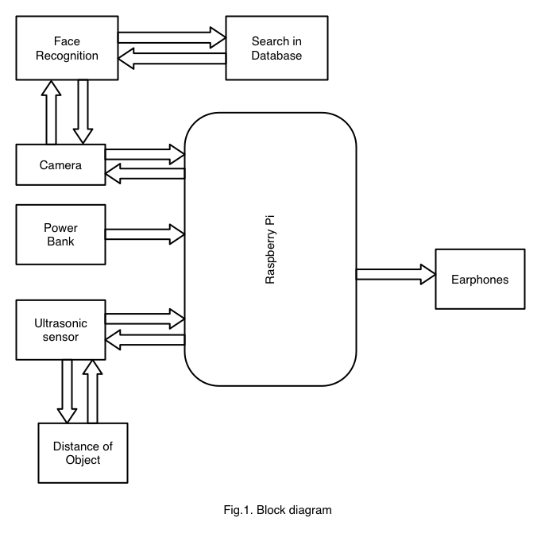

The Key component which manages all the component is Raspberry pi module, it is powered by 5V battery/Power Bank. Other Components used in this project are camera pi module, ultrasonic sensor and earphones. The camera pi module is used to capture the image then recognizes the image captured and compares it with an array of known faces. The ultrasonic sensor is used for measuring the distance between the glasses and the object and the final feedback is delivered in the form of audio output through the earphones to the user wearing it.

# IV.REQUIREMENT ANALYSIS

**Hardware Requirements:**

**Raspberry Pi:** Raspberry Pi 4 is the main component of our “Smart Glasses” project. It is a low-cost embedded system to control and connect all the components together. It uses the Raspbian or NOOBs as the operating system which can accomplish many important tasks.

**Camera:** In the project, the Webcam will be used as the eyes of the person who wears the “Smart Glasses.” The camera is going to capture a picture when the button is pressed, in order to detect and recognize the text from the image.

**Ultrasonic Sensor:** In “Smart Glasses”, the Ultrasonic sensor is used to measure the distance between the camera and an object to detect the text from the text image. The distance should be from 40 cm to 150 cm and that is because this is the required range to capture a clear image.

**Cables and Wires -** These are used to connect all the hardware components to the laptop and Raspberry Pi.

**Battery/Power Bank -** It provides power to all the components.

**Earphone:** It is used to deliver the audio output to the user.

**Glass -** This is the wearable item by the person, in our project on which all the hardware components will be attached.

**Overall Architecture**

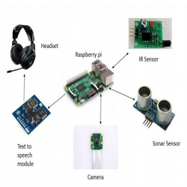

**Software Requirements:**

We are using Python3 for this project.For this project we require two different codes in Python3, one to tell the distance of obstacles ahead and other for face recognition.

Library Modules for python:

1. OpenCV
2. NumPy
3. Dlib
4. Face recognition
5. eSpeak

**Connection:**

After inserting the camera ribbon in camera module, solder the wires of ultrasonic sensor as illustrated below.

|  |  |
| --- | --- |
| Raspberry Pi | Ultrasonic Sensor |
| 5V pin | Vcc |
| GND | GND |
| BCM Pin 27 | TRIG |
| BCM Pin 22 | ECHO |

**V. WORKSPLIT**

|  |  |
| --- | --- |
| **Name** | **Work Done** |
| Nihar Majalikar | Helped with preparing the report and gathering hardware components like ultrasonic sensor. Also helped in the installation of Python libraries. |
| Prakhar Mishra | Helped at conducting literature survey and gathering online resources for the project. |
| Rovel Nazareth | Helped gathered hardware components, such as camera modules, helped create a 3D-printed model of the glasses, and helped with a literature survey. |
| Samarth Gupta | Helped with the report's preparation as well as the Raspberry Pi's installation of Raspbian and the installation of Python libraries. |

# REFERENCES

1. Laurence Devillers, Laurence Vidrascu, Lori Lamel, "Challenges in real–life emotion annotation and machine learning based detection," Neural Networks, 1st ed., Elsevier, 2005, pp. 407 – 422.
2. Terrence Fong, Illah Nourbakhsh, Kerstin Dautenhahn, "A survey of socially interactive robots," Robotics and Autonomous Systems, 1st ed., Elsevier, 2003, pp. 143 – 166.
3. Raspberry Pi. (2018). Raspberry Pi - Teach, Learn, and Make with Raspberry Pi. [online] Available at: <http://www.raspberrypi.org>.
4. Digital Image Processing - Kenneth R. Castleman, PrenticeHall, 1996.
5. T. Ahonen, A. Hadid, and M. Pietik ̈ainen. Face description with local  
   binary patterns: Application to face recognition. IEEE Transactions on  
   Pattern Analysis and Machine Intelligence, 28(12):2037–2041, 2006.
6. M. Bordallo L ́opez, J. Hannuksela, O. Silv ́en, and L. Fan. Head-tracking  
   virtual 3-d display for mobile devices. In Computer Vision and Pattern  
   Recognition Workshops (CVPRW), pages 27–34. IEEE, 2012